**Formulary Preference**

When entering a PA, if the intent of the override is to only cover the preferred, non-preferred or non-formulary products utilize the instructions provided below.

**Always use Ignore PA Status of “N”** (never use other options, because they allow non-formulary NDCs to pay and Molina has a closed NDC-based formulary)

For Rejects “**MR**” and “**75**” follow the below instructions.

* **For claims that are rejecting as MR:** 
  + Use drug status “C”
  + Update MONY codes to IIII
* **For claims that are rejecting as 75 (PA Required). Fax a completed Medication PA Request form to Molina at (877) 281-5364)**
  + Use drug status “a”
  + Attach the formulary preference list "MHC-PREF"
  + Update MONY codes to IIII
* **For Claims that are rejecting as 75 that (Non-Pref NDC). Fax a completed Medication PA Request form to Molina at (877) 281-5364)** 
  + Use drug status “a”
  + Update MONY codes to IIII
* From the Member PA Override Detail screen – Select F17 for “Addnl PA Information”

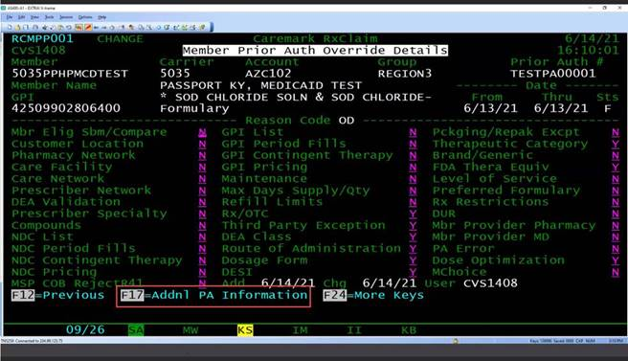

* Select “F4” to access the Formulary Preference List field.

|  |  |
| --- | --- |
| Field | Description |
| Formulary Preference List | When a Preference list is populated, this allows the adjudication engine to decide if the PA is applicable to the claim by the Formulary Preference value on the drug based on the formulary and date of fill. The PA will only apply to the claim if the formulary preference of the claim matches the formulary preference in the attached list |

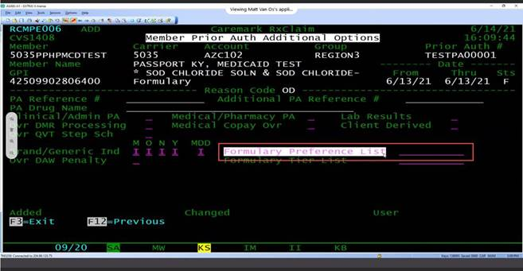

* Search and enter the applicable list ID for the desired intent based on the grid provided below.

|  |  |
| --- | --- |
| **MHC-PREF** | MHC-PREF - MOLINA FORMULARY PREFERRED = Apply PA override only when the incoming drug on the claim is Formulary Preferred. |

**Compass Examples for editing overrides**

